Name: Issa Haddad

ID: 47102

Course: internet programming

Professor: Imran Zualkernan

Q1)

------------------------ index.html ---------------------------------------------------------------------------------------------------

<!doctype html>

<html lang="en">

<head>

<!-- include the necessary styleshhet -->

<meta charset="utf-8">

<link rel="stylesheet" href="lib/onsen/css/onsenui.css">

<link rel="stylesheet" href="lib/onsen/css/onsen-css-components-blue-basic-theme.css">

<link rel="stylesheet" href="range.css">

<link rel="stylesheet" href="css/ex.css">

<!-- include the necessary scripts including: onsen, treeview, jquery-->

<script src="lib/onsen/js/angular/angular.js"></script>

<script src="lib/onsen/js/onsenui.js"></script>

<script src="http://ajax.googleapis.com/ajax/libs/jquery/1.7.1/jquery.min.js"></script>

<script src="http://ajax.googleapis.com/ajax/libs/angularjs/1.0.6/angular.min.js"></script>

<script type="text/javascript" src="cordova.js"></script>

<script>

ons.bootstrap();

</script>

<script>

//angular module

var myApp = angular.module('myApp', ['angularTreeview']);

//controller for myApp

myApp.controller('myController', function($scope){

// get json file from couchdb

$.ajax({

type: "GET",

url: "http://localhost:5984/mid2q1/ID:1/?jsonp=callback",

dataType : 'jsonp',

async: false,

contentType: "application/json",

jsonpCallback: 'callback',

success : function(data){

console.log(data.title);

// assigning scope variables inside the user interface

$scope.$apply(function() {

$scope.roleList = [data];

});

}

});

});

// angular.treeview.js

(function(l){l.module("angularTreeview",[]).directive("treeModel",function($compile){return{restrict:"A",link:function(a,g,c){var e=c.treeModel,h=c.nodeLabel||"label",d=c.nodeChildren||"children",k='<ul><li data-ng-repeat="node in '+e+'"><i class="collapsed" data-ng-show="node.'+d+'.length && node.collapsed" data-ng-click="selectNodeHead(node, $event)"></i><i class="expanded" data-ng-show="node.'+d+'.length && !node.collapsed" data-ng-click="selectNodeHead(node, $event)"></i><i class="normal" data-ng-hide="node.'+

d+'.length"></i> <span data-ng-class="node.selected" data-ng-click="selectNodeLabel(node, $event)">{{node.'+h+'}}</span><div data-ng-hide="node.collapsed" data-tree-model="node.'+d+'" data-node-id='+(c.nodeId||"id")+" data-node-label="+h+" data-node-children="+d+"></div></li></ul>";e&&e.length&&(c.angularTreeview?(a.$watch(e,function(m,b){g.empty().html($compile(k)(a))},!1),a.selectNodeHead=a.selectNodeHead||function(a,b){b.stopPropagation&&b.stopPropagation();b.preventDefault&&b.preventDefault();b.cancelBubble=

!0;b.returnValue=!1;a.collapsed=!a.collapsed},a.selectNodeLabel=a.selectNodeLabel||function(c,b){b.stopPropagation&&b.stopPropagation();b.preventDefault&&b.preventDefault();b.cancelBubble=!0;b.returnValue=!1;a.currentNode&&a.currentNode.selected&&(a.currentNode.selected=void 0);c.selected="selected";a.currentNode=c}):g.html($compile(k)(a)))}}})})(angular);

</script>

</head>

<body>

<!-- onsen template -->

<ons-page>

<ons-toolbar>

<div class="center">Onesn Template Toolbar</div>

</ons-toolbar>

<div ng-app="myApp">

<div ng-controller="myController">

<!-- angular treeview -->

<div

data-angular-treeview="true"

data-tree-model="roleList"

data-node-id="id"

data-node-label="title"

data-node-children="nodes" >

</div>

</div>

</div>

</ons-page>

</body>

</html>

---------------------------------------------------------End of code------------------------------------------------------------------

----------------------------------------------------Screenshots----------------------------------------------------------------------

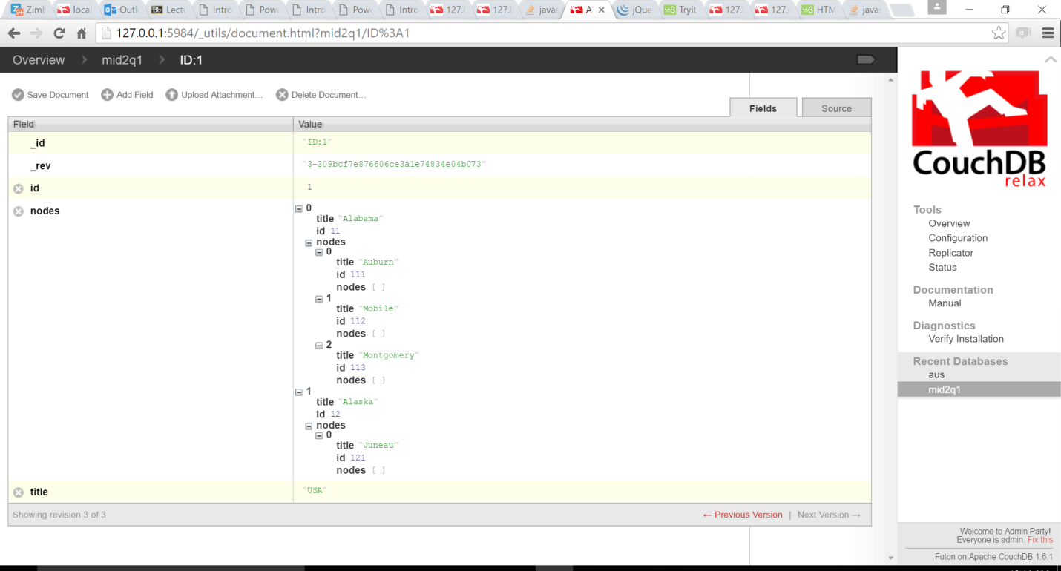

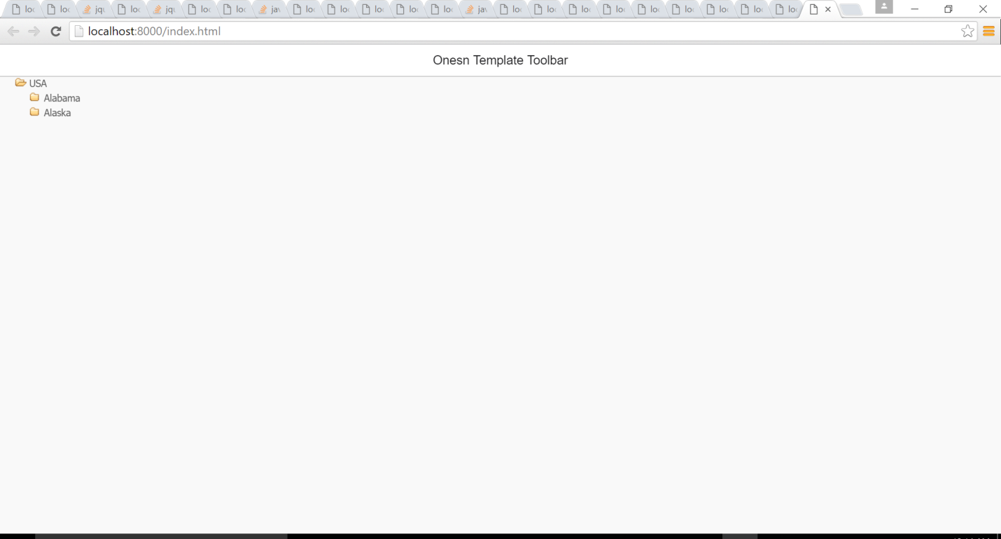

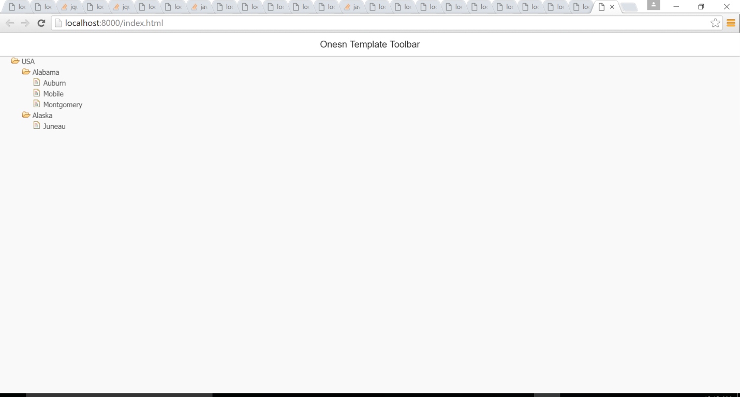

----------------------------------------Screenshots end-----------------------------------------------------------------------------

Q2)

------------------------ index.html ---------------------------------------------------------------------------------------------------

<!DOCTYPE html>

<!-- CSP support mode (required for Windows Universal apps): https://docs.angularjs.org/api/ng/directive/ngCsp -->

<html lang="en" ng-app="app" ng-csp>

<head>

<meta charset="utf-8" />

<meta name="apple-mobile-web-app-capable" content="yes" />

<meta name="mobile-web-app-capable" content="yes" />

<!-- JS dependencies (order matters!) -->

<script src="scripts/platformOverrides.js"></script>

<script src="https://ajax.googleapis.com/ajax/libs/jquery/2.1.3/jquery.min.js"></script>

<script src="lib/angular/angular.min.js"></script>

<script src="lib/onsen/js/onsenui.js"></script>

<script src="lib/jquery.js"></script>

<!-- CSS dependencies -->

<link rel="stylesheet" href="lib/onsen/css/onsenui.css" />

<link rel="stylesheet" href="lib/onsen/css/onsen-css-components-blue-basic-theme.css" />

<link rel="stylesheet" href="lib/onsen/css/ex.css" />

<!-- CSP support mode (required for Windows Universal apps) -->

<link rel="stylesheet" href="lib/angular/angular-csp.css" />

<!-- --------------- App init --------------- -->

<script src="js/app.js"></script>

<script src="mqttws31.js"></script>

<script src="cordova.js"></script>

<script src="scripts/index.js"></script>

<script >

</script>

<title>My App</title>

<style>

.item {

padding: 10px;

line-height: 1;

}

.item-thum {

background-color: #ccc;

width: 50px;

height: 50px;

border-radius: 4px;

}

.item-title {

font-size: 15px;

font-weight: 500;

}

.item-desc {

font-size: 14px;

color: #666;

line-height: 1.3;

margin: 4px 0 0 0;

padding: 0 30px 0 0;

}

.item-label {

font-size: 12px;

color: #999;

float: right;

}

</style>

</head>

<body>

<ons-navigator var="navi">

<ons-page>

<ons-toolbar>

<div class="center">MQTT Client</div>

</ons-toolbar>

<div ng-controller="DetailController">

<div style="margin:10px 0 30px 0; padding:10px; background-color:#EEEEEE; border-radius:5px; font:12px Tahoma;">

<span><b>Selected Node</b> : {{parentone}}</span>

</div>

<div

data-angular-treeview="true"

data-tree-model="roleList"

data-node-id="id"

data-node-label="title"

data-node-children="nodes"

ng-click="printParent($event);" >

</div>

<ons-list modifier="inset" style="margin-top: 10px">

<ons-list-item>

<input type="text" class="text-input text-input--transparent" placeholder="Topic" style="width: 100%" ng-model="topic">

</ons-list-item>

<ons-list-item>

<textarea class="textarea textarea--transparent" placeholder="Message" style="width: 100%; height: 100px;" ng-model="message">

</textarea>

</ons-list-item>

</ons-list>

<div style="padding: 10px 9px">

<ons-button modifier="large" style="margin: 0 auto;" ng-click="doSubscribe()">

Subscribe

</ons-button>

<br>

<ons-button modifier="large" style="margin: 0 auto;" ng-click="doPublish()">

Publish

</ons-button>

</div>

<h2>{{question}}</h2><br>

<ons-list-item modifier="tappable">

<label class="radio-button radio-button--list-item">

<input type="radio" name="b" ng-model="truefalse" value="T">

<div class="radio-button__checkmark radio-button--list-item__checkmark"></div>

True

</label>

</ons-list-item>

<ons-list-item modifier="tappable">

<label class="radio-button radio-button--list-item">

<input type="radio" name="b" ng-model="truefalse" value="F">

<div class="radio-button__checkmark radio-button--list-item__checkmark"></div>

False

</label>

</ons-list-item>

<div style="padding: 10px 9px">

<ons-button modifier="large" style="margin: 0 auto;" ng-click="submit()">

Send

</ons-button>

</div>

</div>

</ons-page>

</body>

</html>

---------------------------------------------------------End of code------------------------------------------------------------------

---------------------------------------------------------App.js-------------------------------------------------------------------------

(function(){

'use strict';

var module = angular.module('app', ['onsen','angularTreeview']);

module.controller('DetailController', function($scope, $mqtt) {

$.ajax({

type: "GET",

url: "http://localhost:5984/mid2q2/ID:1/?jsonp=callback",

dataType : 'jsonp',

async: false,

contentType: "application/json",

jsonpCallback: 'callback',

success : function(data){

console.log(data.title);

// assigning scope variables inside the user interface

$scope.$apply(function() {

$scope.roleList = [data];

});

}

});

$scope.printParent = function ($event) {

var root = $scope;

var currentScope = angular.element($event.target).scope();

var clicked = currentScope.node.title;

console.log('selected Node details: ', currentScope.node);

currentScope = currentScope.$parent;

console.log('parents::')

$scope.parentone ="";

while(currentScope.$id !== root.$id) {

console.log(currentScope.node);

$scope.parentone = currentScope.node.title + "/" + $scope.parentone ;

currentScope = currentScope.$parent;

}

$scope.parentone = $scope.parentone + clicked;

$scope.topic = $scope.parentone;

}

$scope.doSubscribe = function() {

console.log($scope.topic);

$mqtt.subscribe($scope.topic);

};

$scope.doPublish = function() {

console.log($scope.topic);

console.log($scope.message);

$mqtt.publish($scope.topic,$scope.message);

$scope.question = $scope.message;

};

$scope.submit = function(){

var grade= "False";

if($scope.truefalse=="T"){

grade="Correct";

}

window.alert("your answer is: " + grade);

};

});

module.factory('$mqtt', function() {

var wsbroker = "localhost"; //mqtt websocket enabled broker

var wsport = 3000 // port for above

var client = new Paho.MQTT.Client(wsbroker, wsport,

"myclientid_" + parseInt(Math.random() * 100, 10));

client.onConnectionLost = function (responseObject) {

console.log("connection lost: " + responseObject.errorMessage);

};

client.onMessageArrived = function (message) {

console.log(message.destinationName, ' -- ', message.payloadString);

};

var options = {

timeout: 3,

onSuccess: function () {

console.log("mqtt connected");

},

onFailure: function (message) {

console.log("Connection failed: " + message.errorMessage);

}

};

// will connect only once

client.connect(options);

return{

subscribe : function(topic){

client.subscribe(topic, {qos: 1});

},

publish: function(topic, msg) {

var message = new Paho.MQTT.Message

(msg);

message.destinationName = topic;

client.send(message);

}}

});

})();

(function(l){l.module("angularTreeview",[]).directive("treeModel",function($compile){return{restrict:"A",link:function(a,g,c){var e=c.treeModel,h=c.nodeLabel||"label",d=c.nodeChildren||"children",k='<ul><li data-ng-repeat="node in '+e+'"><i class="collapsed" data-ng-show="node.'+d+'.length && node.collapsed" data-ng-click="selectNodeHead(node, $event)"></i><i class="expanded" data-ng-show="node.'+d+'.length && !node.collapsed" data-ng-click="selectNodeHead(node, $event)"></i><i class="normal" data-ng-hide="node.'+

d+'.length"></i> <span data-ng-class="node.selected" data-ng-click="selectNodeLabel(node, $event)">{{node.'+h+'}}</span><div data-ng-hide="node.collapsed" data-tree-model="node.'+d+'" data-node-id='+(c.nodeId||"id")+" data-node-label="+h+" data-node-children="+d+"></div></li></ul>";e&&e.length&&(c.angularTreeview?(a.$watch(e,function(m,b){g.empty().html($compile(k)(a))},!1),a.selectNodeHead=a.selectNodeHead||function(a,b){b.stopPropagation&&b.stopPropagation();b.preventDefault&&b.preventDefault();b.cancelBubble=

!0;b.returnValue=!1;a.collapsed=!a.collapsed},a.selectNodeLabel=a.selectNodeLabel||function(c,b){b.stopPropagation&&b.stopPropagation();b.preventDefault&&b.preventDefault();b.cancelBubble=!0;b.returnValue=!1;a.currentNode&&a.currentNode.selected&&(a.currentNode.selected=void 0);c.selected="selected";a.currentNode=c}):g.html($compile(k)(a)))}}})})(angular);

---------------------------------------------------------End of code------------------------------------------------------------------

---------------------------------------------------------ex.css--------------------------------------------------------------------------

div[data-angular-treeview] {

/* prevent user selection */

-moz-user-select: -moz-none;

-khtml-user-select: none;

-webkit-user-select: none;

-ms-user-select: none;

user-select: none;

/* default */

font-family: Tahoma;

font-size:13px;

color: #555;

text-decoration: none;

}

div[data-tree-model] ul {

margin: 0;

padding: 0;

list-style: none;

border: none;

overflow: hidden;

}

div[data-tree-model] li {

position: relative;

padding: 0 0 0 20px;

line-height: 20px;

}

div[data-tree-model] li .expanded {

padding: 1px 10px;

background-image: url("http://cfile23.uf.tistory.com/image/205B973A50C13F4B19D9BD");

background-repeat: no-repeat;

}

div[data-tree-model] li .collapsed {

padding: 1px 10px;

background-image: url("http://cfile23.uf.tistory.com/image/1459193A50C13F4B1B05FB");

background-repeat: no-repeat;

}

div[data-tree-model] li .normal {

padding: 1px 10px;

background-image: url("http://cfile23.uf.tistory.com/image/165B663A50C13F4B196CCA");

background-repeat: no-repeat;

}

div[data-tree-model] li i, div[data-tree-model] li span {

cursor: pointer;

}

div[data-tree-model] li .selected {

background-color: #aaddff;

font-weight: bold;

padding: 1px 5px;

}

---------------------------------------------------------End of code------------------------------------------------------------------

----------------------------------------------------Screenshots----------------------------------------------------------------------

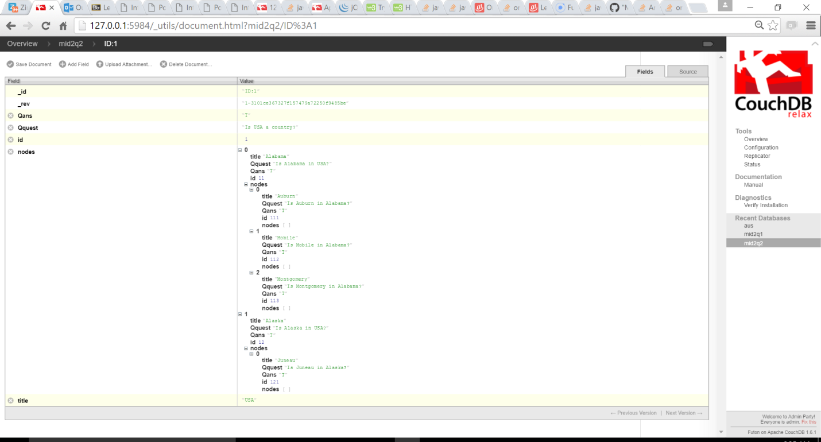

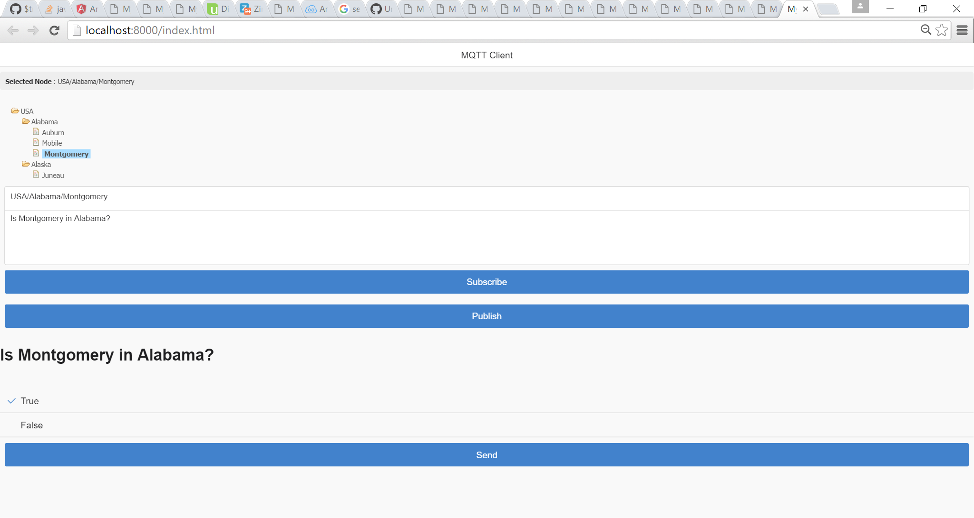

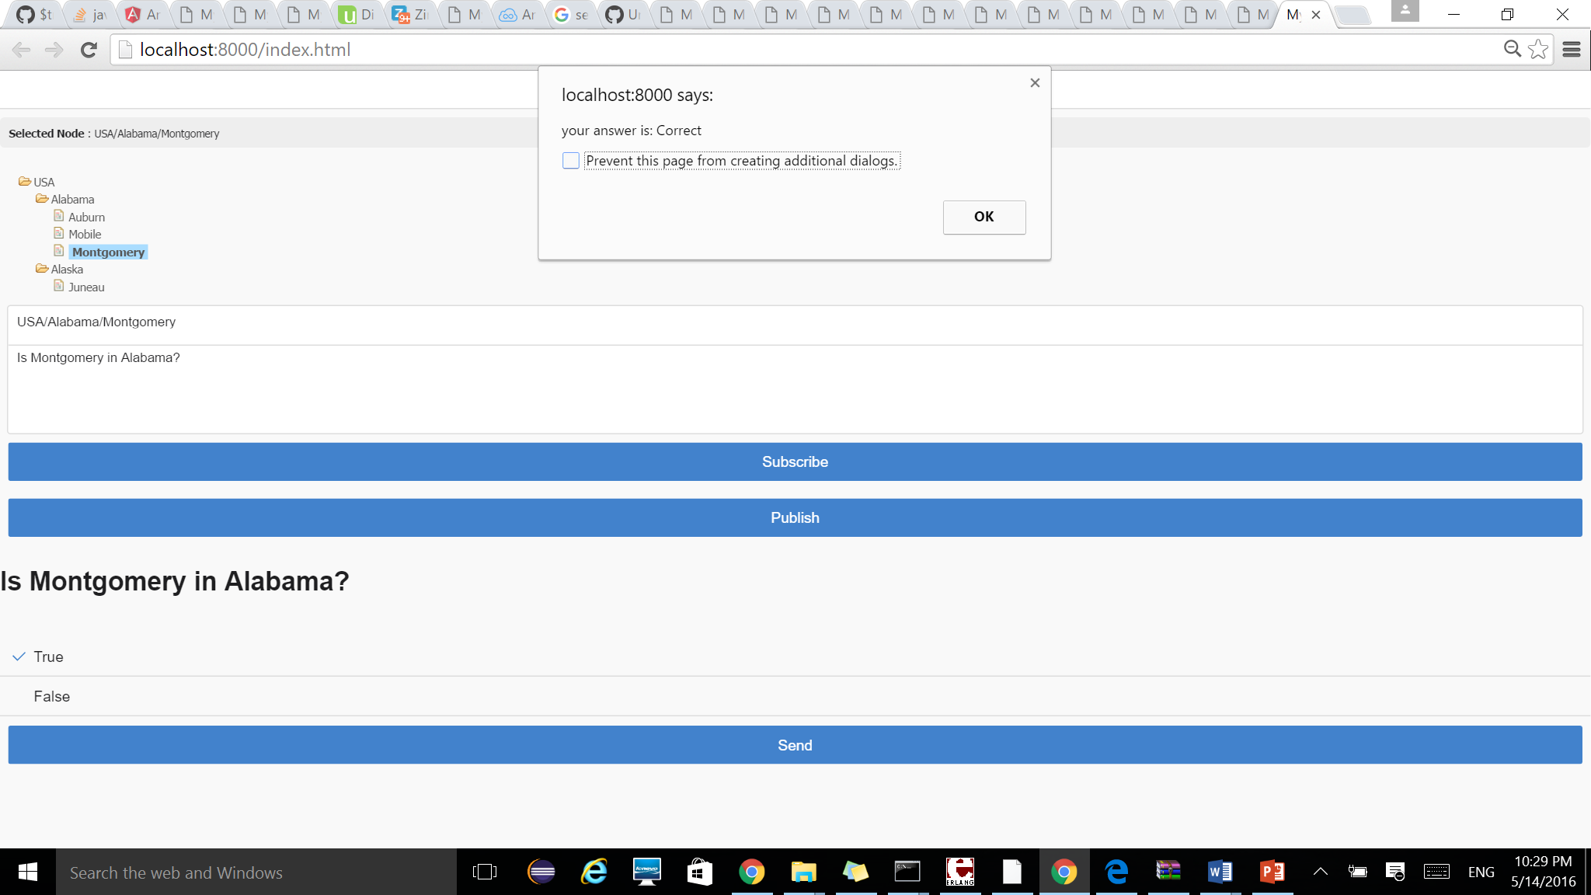

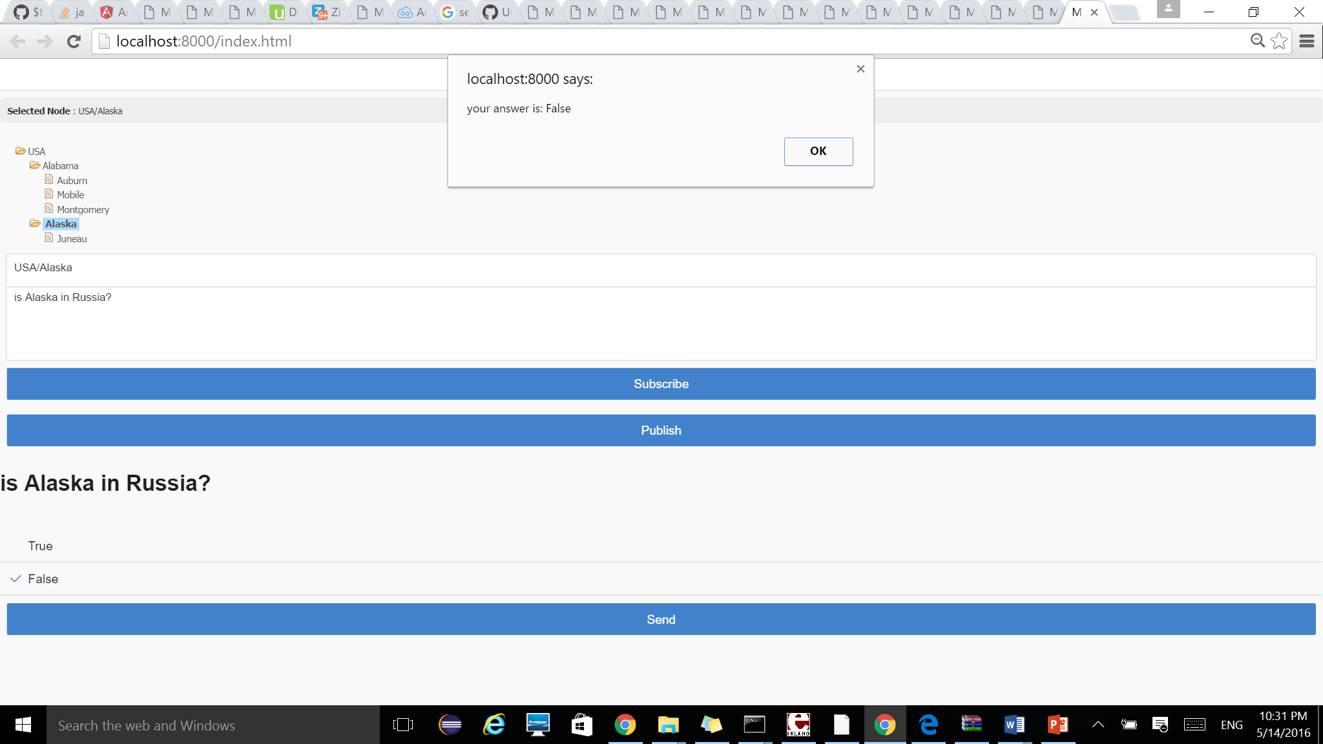

----------------------------------------------------Screenshots end-----------------------------------------------------------------

Link to video: (share.aus.edu) is down

🡪 <https://www.dropbox.com/s/76ts1dee6mcqkel/Midterm%202%20question%202.mp4?dl=0>